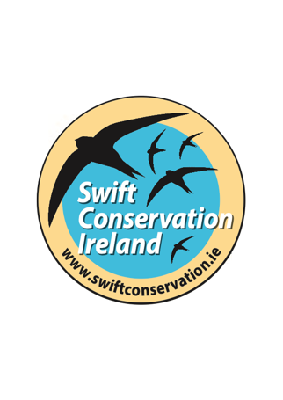
swiftconservationireland@gmail.com
www.swiftconservation.ie
1 October 2021

Re: County Carlow Council Development Plan 2022-2028

Swift Conservation Ireland would like to recommend that Carlow County Council consider various conservation actions for the Swift Apus apus in the County Development Plan for 2022-2028.

Some background information about the Swift
- The Swift is a Red-listed bird of conservation concern in Ireland with a decline of close to 50% in the last 30 years – mostly due to loss of nest site.
- The Swift is an important and unique part of urban biodiversity because the majority of their nests are found in old urban buildings.
- They are totally faithful to their nest sites returning to the same one for the duration of their life. Loss of these nest sites caused by building renovation or demolition has been the main cause of the population decline.
- They winter in Africa but do not breed there. They only breed at their European nest sites which makes Ireland and other European countries an extremely important location for the future of the species.
- They come to Ireland’s towns to breed, arriving in late April/earlyMay and departing in late August each year.
- They spend most of their life on the wing, flying, and only land at their nest site to lay eggs and rear their young.
- Although they nest in our buildings they DO NOT cause any public nuisance and DO NOT leave any droppings under the nests which makes them an ideal town inhabitant
- They feed on airborne insects including midges and aphids and so provide a good eco service by consuming thousands of flying insects.
- There is no risk of spread of zoonotic disease or spread of disease to domestic livestock/companion animals.
How to help protect and increase Swift numbers
- The best way of helping to protect and increase Swift numbers is to provide artificial nest boxes. The most long-term and thus the most successful is when nest boxes are built into the walls of new public buildings e.g. schools, libraries etc. Such projects are being implemented to great effect in counties around Ireland and it would be of great benefit if Carlow county could get involved.
Building in swift boxes in public buildings helps to raise awareness not just about the Swift but about urban biodiversity and having a healthy environment. It may also help towards achieving and obtaining the LEED and/or BREEAM building standard for sustainable new construction projects in Ireland.
When installing a Swift nest box project it is very important to a swift attraction call system because this helps the Swifts locate the entrance holes whilst in flight. The attraction calls only need to be played from May to August each year and until the Swifts take up occupancy – which can take up to three years.
- A county-wide survey could be commissioned to establish the state of the county’s Swift population. This would involve surveying each town/village in the breeding season (May to end August). Such a survey would also help identify appropriate locations for Swift nest box projects.

- A workshop could be held for architects, planners, heritage officer etc. to advise them best practice when protecting Swift colonies in old buildings and establishing nest box projets.

- In a wider context the Carlow County Development Plan could adopt a policy of building for biodiversity to ensure nesting and breeding places are available for birds and bats in buildings. In addition, establishing green corridors and green roofs on buildings all help to enhance urban biodiversity.

You can find additional information about the Swift and Swift nest box projects at www.swiftconservation.ie and in the booklet ‘We are Swifts, We are in Trouble’ which is in pdf on the home page of the website.
Swift Conservation Ireland would be willing to provide advice and support for any Swift Conservation actions in County Carlow.

Yours faithfully,
Lynda Huxley
Swift Conservation Ireland
swiftconservationireland@gmail.com

