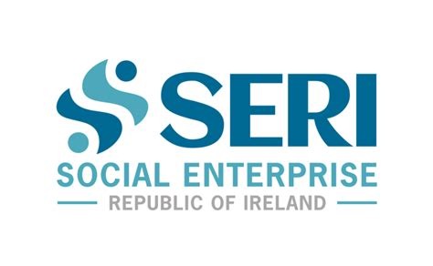

Social Enterprise
Republic of Ireland

Carlow
County Development Plan Submission

July 21 2021

To. Carlow County Council
From. Tammy Darcy, CEO SERI: Social Enterprise Republic of Ireland
Subject. Preparation of future Carlow County Development Plan
Issue. Social Enterprise in Carlow
Date. July 21 2021

To whom it may concern,

As Social Enterprise Republic of Ireland (SERI – www.socialenterprise.ie),the representative body for Social Enterprises in Ireland, we strongly believe that the following items should be included as key commitments in the future Carlow County Development Plan:

- A commitment to facilitate, enable and support the development of a vibrant Social Enterprise sector, as a valuable and important component of the overall Economic Development vision.

Social Enterprise is responsible for a significant level of service delivery, employment and facilities across education, housing, healthcare, childcare, tourism, sport and recreation, culture, heritage and the arts, energy, recycling and environmental initiatives. It is an essential pillar in the regeneration of many communities with many people dependent on social enterprises for essential supports. The Local Authority should ensure that relevant staff have knowledge of the challenges faced by social enterprises and that social enterprises have access to enterprise support structures and supports.

- A commitment to work with Social Enterprises to access and develop appropriate fit for purpose land and buildings as spaces to enable development and growth of new services and products.

Social Enterprises require access to facilities to grow and develop their business services and products. Lacking access to essential capital to facilitate self-funded development, Social Enterprises require Local Authorities to have a greater awareness of their needs and incorporate Social Enterprises into local regeneration and other plans. Proactive approaches to provide infrastructural and service supports to facilitate Social Enterprises will create synergies, networking and the potential for collaboration.

- A commitment to include Social Clauses in Public Procurement.

Social Enterprises require more accessible forms of Public Procurement in order to participate and benefit from state funded contracts. Local Authorities can facilitate this in how they structure their public procurement exercises when delivering on the County Development Plan investments. Social Clauses can be introduced making Public Procurement tenders more accessible for Social Enterprises.

- A commitment to identity and disseminate best practice local examples of social enterprises and increase public understanding of their contribution to society and the economy.

SERI will continue to communicate the social enterprise agenda in a co-ordinated way, however, it is important that the Local Authority also underpin that messaging to ensure coherence and to improve public understanding of social enterprise as a whole, and its contribution to society and the economy. This messaging can also provide ideas and inspiration for communities in meeting identified community services and product needs.

Social Enterprise Republic of Ireland (SERI is available and open to meeting with Carlow Local Authority and advising how they might better support local Social Enterprises based on identified needs.

If you would like any further information, please do not hesitate to contact me on 087-9842505 or at tammy@socialenterprise.ie

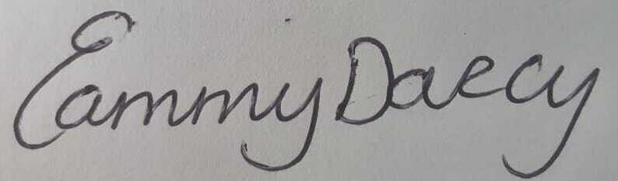
CEO, SERI: Social Enterprise Republic of Ireland

SERI County Development Plan Submission Notes

- Background to Social Enterprise Republic of Ireland

SERI, established in 2020, is a company limited by guarantee, born from the passion and knowledge within the Social Enterprise sector and responding to a universally recognised need for a united voice. Formed by some of Irelands leading social enterprise practitioners and supporters, SERI seeks to champion for the sector and members, representing and promoting its collective voice, both nationally and internationally.

SERI is a new beginning for Social Enterprise in Ireland and will grow the sector to benefit all people and communities by working shoulder to shoulder with local and national government to deliver a better eco system for social enterprises in which to operate.

SERI focuses on 4 main areas;
- Representation–listening to members, championing, advocating, and representing.
- Awareness–generating more understanding, demonstrating value, telling stories.
- Support–signposting supports, identifying gaps, sharing best practice, networking.
- Relationships–with Government, international orgs, N.I., other SE support organisations.

- The Social Enterprise Sector in Ireland

The spectrum of social enterprise activity in Ireland is wide, and social enterprises take a variety of different forms, including, amongst others:
- Work Integration Social Enterprises (WISEs), which support disadvantaged people to prepare for, and participate in, the labour market.
- Enterprise Development social enterprises which support the creation of other enterprises (e.g. through the provision of office space and facilities).
- ‘Deficient Demand’ social enterprises which seek to meet a demand for goods and services within a community where there is insufficient demand for the operation of a regular market due to inherent economic and social disadvantage or low density of population.
- Environmental social enterprises which focus on environmental sustainability.
- Social enterprises contracted with the public sector to deliver public services in disadvantaged areas and communities.
- Some cooperatives which do not distribute profits to shareholders and are established to achieve a clear social impact also utilise the social enterprise model.

The activities of some social enterprises can cut across more than one of these areas.

- Recent Development for Social Enterprise In Ireland

- 2013 Government produced a report on social enterprise.
- 2014 Minister for State Sean Sherlock TD given the social enterprise portfolio to develop.
- 2016 Minister for State Ann Phelan TD succeeded Minister Sherlock TD.
- 2016 Minister Michael Ring TD established the Department of Rural & Community Development with responsibility for Social Enterprise.
- 2017 Government assigned policy responsibility for social enterprise to the newly established Department of Rural and Community Development.
- 2018 In Dublin in July, Minister Michael Ring TD launched the National Social Enterprise Policy for Ireland 2019-2022.
- 2020 Minister Humphries TD leads the implementation of the social Enterprise Policy.

- National Social Enterprise Policy

The national Policy defines Social Enterprise as “an enterprise whose objective is to achieve a social, societal or environmental impact rather than maximising profit for its owners or shareholders. It pursues its objectives by trading on an ongoing basis through the provision of goods and/or services and by reinvesting surpluses into achieving social objectives. It is governed in a fully accountable and transparent manner and independent of the public sector. If dissolved it should transfer its assets to another organisation with a similar mission”.

The Policy is focused on three objectives to support Social Enterprise growth:

- Building Awareness of Social Enterprise
- Growing and Strengthening Social Enterprise
- Achieving Better Policy Alignment

The Policy sets out a series of 26 commitments on the part of Government across these three Objectives for the development of social enterprise over the period 2019-2022. These commitments will be delivered in partnership with social enterprise stakeholders. The objective of the Policy is to support social enterprise to grow in scale and impact.

- Social Enterprise and Local Authorities

Local Authorities play a key role in leading the social, economic and cultural development of local areas. Local Authorities are involved in the delivery of a range of supports to social enterprises through initiatives such as the Social Inclusion and Community Activation Programme (SICAP), and the Community Enhancement Programme. Local Authorities Ireland has also worked with Social Innovation Fund Ireland (SIFI) and IPB Insurance on the €1.6 million Social Enterprise Development Fund which is being delivered by SIFI over the period 2018-2020.

