Planning & Development Regulations 2001 (As Amended)
EIA Screening
Site Location:
The proposed site is located on the grounds of Carlow College. The college is significant nationally in that it is the oldest catholic 3rd level institution in the country, founded in 1782. The proposed site is in front of the recently constructed Visual Centre. It is on grounds that has been disturbed as part of the construction of Visual. The site was also never built on as part of the evolution of Carlow College. The scope of the exposed works will involve minimal excavation as the proposal consists of primarily resurfacing work.

Planning Status:
- Located on ‘Town Centre’ zoned land in the current Joint Spatial Plan for the Greater Carlow Graiguecullen Urban Area 2012-2018 (as extended).
- Site is not located inside an Architectural Conservation Area (ACA) in the Joint Spatial Plan.
- The proposal is not listed as a Protected Structure in the current Joint Spatial Strategy or the Carlow County Development Plan. The proposal is not on the NIAH register but the site is within the curtilage of Carlow College a protected structure (RPS No. CT73, NIAH Number 10000437).
- Site is not located inside OPW Flood Zone A and B in flood mapping available for the area.
- The boundary of the site is circa 355m north east of the River Burrin, which feeds into the River Barrow & River Suir SAC (Site Code: 002162) which is about 410m to the west of the site boundary.
- The proposed site is located within the Cultural Quarter as identified under the current Joint Spatial Plan for the Greater Carlow Graiguecullen Urban Area 2012-2018 (as extended).

Proposed Local Authority Development Works:
Short Term Works:
- The project proposes the resurfacing of the public pedestrian path in front of the main entrance to Visual.
- It is also proposed to resurface some of the grass area around Eileen McDonagh’s tree sculpture, while still retaining the grass bank in front of the Lennon’s terrace area.
- We are also proposing a series of new lamp standards to improve the lighting along the pedestrian path.
- The project includes a proposed signage “Totem” which will draw visitors who arrive at the car park to the rear of Visual, around to the buildings actual entrance. It is also proposed to install new directional signage at the end of the Gabion bag wall in the carpark to direct arrivals to the front of Visual.
- The proposal will also include the installation of a tourist information point in front of Visual as part of the Visitor Hub experience.
- It is proposed to install a retaining / planter / bench wall to facilitate the resurfacing of the area around the tree sculpture.

Medium Term works:
No medium term works planned.

Long Term Works:
No long term works planned.

Planning & Development Regulations 2001 Schedule 5 (Relevant EIA Categories)
Mandatory EIA Listed Projects & Thresholds | Proposed Development
Schedule 5, Part 2  Paragraph 10 (iv) - Urban development which would involve an area greater than 2 hectares in the case of a business district, 10 hectares in the case of other parts of a built-up area and 20 hectares elsewhere.  (In this paragraph, “business district” means a district within a city or town in which the predominant land use is retail or commercial use.) | The subject site consists of a site area of approximately 0.025 ha.  The proposed development is significantly less than the mandatory EIA threshold based on the site area involved.
Schedule 5 Part 2  Paragraph 15 - Any project listed in this Part which does not exceed a quantity, area or other limit specified in this Part in respect of the relevant class of development but which would be likely to have significant effects on the environment, having regard to the criteria set out in Schedule 7. | See Schedule 7 Assessment below.

Schedule 7
CRITERIA FOR DETERMINING WHETHER DEVELOPMENT LISTED IN PART 2 OF SCHEDULE 5 SHOULD BE SUBJECT TO AN ENVIRONMENTAL IMPACT ASSESSMENT
1. Characteristics of proposed development  The characteristics of proposed development, in particular—  (a) the size and design of the whole of the proposed development,  (b) cumulation with other existing development and/or development the subject of a consent for proposed development for the purposes of section 172(1A)(b) of the Act and/or development the subject of any development consent for the purposes of the Environmental Impact Assessment Directive by or under any other enactment,  (c) the nature of any associated demolition works,  (d) the use of natural resources, in particular land, soil, water and biodiversity,  (e) the production of waste,  (f) pollution and nuisances,  (g) the risk of major accidents, and/or disasters which are relevant to the project concerned, including those caused by climate change, in accordance with scientific knowledge, and  (h) the risks to human health (for example, due to water contamination or air pollution). | (a)The site size is approximately 0.025 ha. Works proposed are considered minor in nature with minimal interference with the built fabric of both Visual and Carlow College.  (b) No significant cumulative effects are noted with existing development or consented development in the area.  (c) Minor demolition works are being proposed as part of the upgrading of existing surfacing.  (d) No significant impact is anticipated with the use of natural resources. An Appropriate Assessment Screening Report has also been carried out which concluded that no significant impact will arise from the proposed work on the nearest Natura 2000 Site (River Barrow & River Suir SAC).  (e) No significant production of waste will occur.  (f) No significant pollution or nuisance effects will occur. Please see attached separately a Appropriate assessment screening report.  (g) Proposed works are minor in scale to upgrade the public realm space in front of Visual. No major risk posed by major accidents and/or disasters to the project proposed.  (h) No significant risk to human health will arise from the proposed works.
2. Location of proposed development  The environmental sensitivity of geographical areas likely to be affected by the proposed development, with particular regard to—  (a) the existing and approved land use,  (b) the relative abundance, availability, quality and regenerative capacity of natural resources (including soil, land, water and biodiversity) in the area and its underground,  (c) the absorption capacity of the natural environment, paying particular attention to the following areas:  (i) wetlands, riparian areas, river mouths;  (ii) coastal zones and the marine environment;  (iii) mountain and forest areas;  (iv) nature reserves and parks;  (v) areas classified or protected under legislation, including Natura 2000 areas designated pursuant to the Habitats Directive and the Birds Directive and;  (vi) areas in which there has already been a failure to meet the environmental quality standards laid down in legislation of the European Union and relevant to the project, or in which it is considered that there is such a failure;  (vii) densely populated areas;  (viii) landscapes and sites of historical, cultural or archaeological significance. | - Currently in use as a public space and pedestrian circulation route.  - The proposed works are minor in nature and are aimed at improving the public realm space and visitor experience to Carlow. The proposed works are not likely to have any impacts on natural resources in the area and its underground.  (c)  - (i) The site does not directly adjoin the River Barrow or Burrin. The site is not located inside a Flood Zone (OPW CFRAM - flood risk areas).  - (ii) Not applicable.  - (iii) Not applicable.  - (iv) Not applicable.  - (v) Not Applicable.  - (vi) Not applicable.  - (vii) The site is located in town centre, with some residential use in the wider area, but it is not densely populated with residential use.  - (viii) The proposed site is located within the curtilage and attendant grounds of Carlow College, a protected structure. The proposed project does not involve any works to buildings that are protected. Please refer to the attached Architectural Heritage Impact Assessment. The proposed site is outside the zone of notification for Archaeological Interest. Despite that fact we also attached an Archaeological Impact Appraisal for the proposed project.
3. Types and characteristics of potential impacts  The likely significant effects on the environment of proposed development in relation to criteria set out under paragraphs 1 and 2, with regard to the impact of the project on the factors specified in paragraph (b)(i)(I) to (V) of the definition of ‘environmental impact assessment report’ in section 171A of the Act, taking into account—  (a) the magnitude and spatial extent of the impact (for example, geographical area and size of the population likely to be affected),  (b) the nature of the impact,  (c) the transboundary nature of the impact,  (d) the intensity and complexity of the impact,  (e) the probability of the impact,  (f) the expected onset, duration, frequency and reversibility of the impact,  (g) the cumulation of the impact with the impact of other existing and/or development the subject of a consent for proposed development for the purposes of section 172(1A)(b) of the Act and/or development the subject of any development consent for the purposes of the Environmental Impact Assessment Directive by or under any other enactment, and  (h) the possibility of effectively reducing the impact | The proposed development is not likely to have significant effects on the environment taking into account the criteria listed in Paragraphs 1 and 2.  The proposed works are minor in scale and timeframe. No significant impact will arise on land use or populations within or adjoining the site, or cumulatively with adjacent exiting or proposed development in the area.  The proposal has also been subject to an Appropriate Assessment Screening examination (see separate report attached). No significant impact will arise from the proposed development.  There is no likely significant effects on the environment noted for the proposed development and the need for a EIA can be screened out under the criteria listed in Schedule 7 of the Planning & Development Regulations 2001 (as amended).

____________________ | Date:___________________
SIGNED BY:

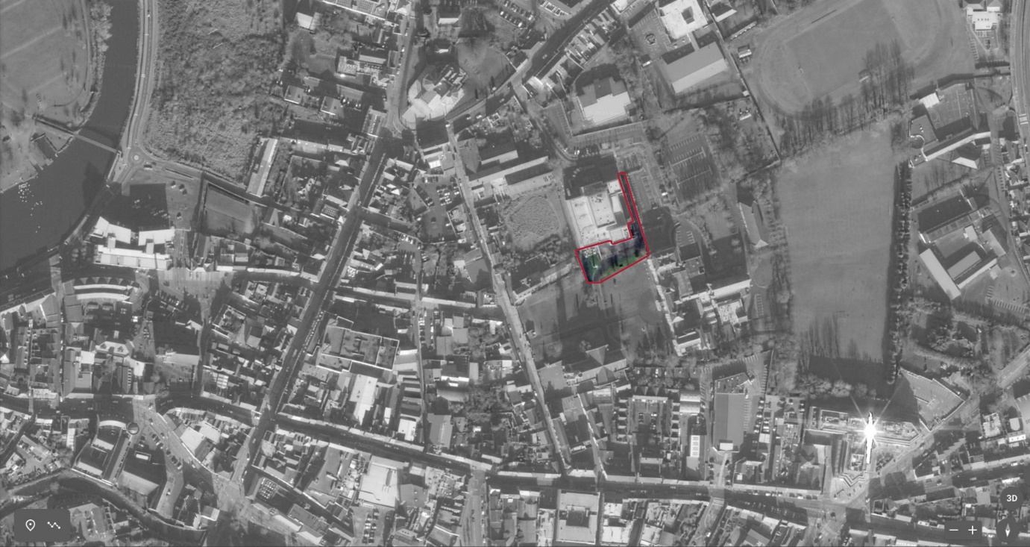
Aerial view of the proposed site outlined in red.
Ordinance Survey Map showing the site location.

