Planning & Development Regulations 2001 (As Amended)
EIA Screening
Site Location:
The property is the ruin of a 19th century building, currently one storey high, built in coursed rubble stonework with the remains of brick window surrounds. The property is located on the western boundary of Potato Market and is in a derelict state, with roof and internal floors having collapsed at some point in the past and no remnants of the collapse left on site. The land to the east is a public plaza. The land to the south and west is currently a public car park and laneway. To the north of the site is an occupied two storey building, accommodating a clothes retail business.

Planning Status:
- Located on ‘Town Centre’ zoned land in the current Joint Spatial Plan for the Greater Carlow Graiguecullen Urban Area 2012-2018 (as extended).
- The proposed site is adjacent to Opportunity Site 4: Plas na Saoirse and Potato Market.
- Site is not located inside an Architectural Conservation Area (ACA) in the Joint Spatial Plan.
- It is not listed as a Protected Structure in the current Joint Spatial Strategy or the Carlow County Development Plan. The building is also not on the NIAH register.
- Site is not located inside OPW Flood Zone A and B in flood mapping available for the area.
- The boundary of the site is circa 83m north east of the River Burrin, which feeds into the River Barrow & River Suir SAC (Site Code: 002162).

Proposed Local Authority Development Works:
Short Term Works:
- The loose stones at the top of the wall are to be reset.
- The access to the site from the street to be retained with a new gate structure going in.
- The new access gate to the western corner is to be instated to allow both vehicular and pedestrian access.
- The existing mini pillar to the car park boundary wall is to be moved.
- A new steel portal frame structure is to be instated independent of the existing stone walls to support the proposed standing seam metal roof.
- The clear-storey spaces between the roofs are to be infilled with a polycarbonate rainscreen system.

Medium Term works:
No medium term works planned.

Long Term Works:
No long term works planned.

Planning & Development Regulations 2001 Schedule 5 (Relevant EIA Categories)
Mandatory EIA Listed Projects & Thresholds | Proposed Development
Schedule 5, Part 2  Paragraph 10 (iv) - Urban development which would involve an area greater than 2 hectares in the case of a business district, 10 hectares in the case of other parts of a built-up area and 20 hectares elsewhere.  (In this paragraph, “business district” means a district within a city or town in which the predominant land use is retail or commercial use.) | The subject site consists of a site area of approximately 0.034ha.  The proposed development is significantly less than the mandatory EIA threshold based on the site area involved.
Schedule 5 Part 2  Paragraph 15 - Any project listed in this Part which does not exceed a quantity, area or other limit specified in this Part in respect of the relevant class of development but which would be likely to have significant effects on the environment, having regard to the criteria set out in Schedule 7. | See Schedule 7 Assessment below.

Schedule 7
CRITERIA FOR DETERMINING WHETHER DEVELOPMENT LISTED IN PART 2 OF SCHEDULE 5 SHOULD BE SUBJECT TO AN ENVIRONMENTAL IMPACT ASSESSMENT
1. Characteristics of proposed development  The characteristics of proposed development, in particular—  (a) the size and design of the whole of the proposed development,  (b) cumulation with other existing development and/or development the subject of a consent for proposed development for the purposes of section 172(1A)(b) of the Act and/or development the subject of any development consent for the purposes of the Environmental Impact Assessment Directive by or under any other enactment,  (c) the nature of any associated demolition works,  (d) the use of natural resources, in particular land, soil, water and biodiversity,  (e) the production of waste,  (f) pollution and nuisances,  (g) the risk of major accidents, and/or disasters which are relevant to the project concerned, including those caused by climate change, in accordance with scientific knowledge, and  (h) the risks to human health (for example, due to water contamination or air pollution). | (a)The site size is approximately 0.034ha. Works proposed are considered minor in nature with minimal interference with the remaining orginal fabric.  (b) No significant cumulative effects are noted with existing development or consented development in the area.  (c) Minor demolition works are being proposed.  (d) No significant impact is anticipated with the use of natural resources. An Appropriate Assessment Screening Report has also been carried out which concluded that no significant impact will arise from the proposed work on the nearest Natura 2000 Site (River Barrow & River Suir SAC).  (e) No significant production of waste will occur.  (f) No significant pollution or nuisance effects will occur. Please see attached separately a Noise Impact Study.  (g) Proposed works are minor in scale in order to roof over the vacant site. No major risk posed by major accidents and/or disasters to the project proposed.  (h) No significant risk to human health will arise from the proposed works.
2. Location of proposed development  The environmental sensitivity of geographical areas likely to be affected by the proposed development, with particular regard to—  (a) the existing and approved land use,  (b) the relative abundance, availability, quality and regenerative capacity of natural resources (including soil, land, water and biodiversity) in the area and its underground,  (c) the absorption capacity of the natural environment, paying particular attention to the following areas:  (i) wetlands, riparian areas, river mouths;  (ii) coastal zones and the marine environment;  (iii) mountain and forest areas;  (iv) nature reserves and parks;  (v) areas classified or protected under legislation, including Natura 2000 areas designated pursuant to the Habitats Directive and the Birds Directive and;  (vi) areas in which there has already been a failure to meet the environmental quality standards laid down in legislation of the European Union and relevant to the project, or in which it is considered that there is such a failure;  (vii) densely populated areas;  (viii) landscapes and sites of historical, cultural or archaeological significance. | - Currently in a derelict state. Site is located in town centre and adjoins an existing clothes retail business to the immediate northwest.  - The proposed works are minor in nature to roof over the existing vacant site. The proposed works are not likely to have any impacts on natural resources in the area and its underground.  (c)  - (i) The site does not directly adjoin the River Barrow or Burrin. The site is not located inside a Flood Zone (OPW CFRAM - flood risk areas).  - (ii) Not applicable.  - (iii) Not applicable.  - (iv) Not applicable.  - (v) Not Applicable.  - (vi) Not applicable.  - (vii) The site is located in town centre, with some residential use above ground floors, but is not densely populated with residential use.  - (viii) The ruined walls of the site are of some historical and archaeological interest but are not protected. Please refer to the attached AIA The proposed works will be sympathetic to the remaining walls and help to stabilise same for future use by providing them with better weather protection.
3. Types and characteristics of potential impacts  The likely significant effects on the environment of proposed development in relation to criteria set out under paragraphs 1 and 2, with regard to the impact of the project on the factors specified in paragraph (b)(i)(I) to (V) of the definition of ‘environmental impact assessment report’ in section 171A of the Act, taking into account—  (a) the magnitude and spatial extent of the impact (for example, geographical area and size of the population likely to be affected),  (b) the nature of the impact,  (c) the transboundary nature of the impact,  (d) the intensity and complexity of the impact,  (e) the probability of the impact,  (f) the expected onset, duration, frequency and reversibility of the impact,  (g) the cumulation of the impact with the impact of other existing and/or development the subject of a consent for proposed development for the purposes of section 172(1A)(b) of the Act and/or development the subject of any development consent for the purposes of the Environmental Impact Assessment Directive by or under any other enactment, and  (h) the possibility of effectively reducing the impact | The proposed development is not likely to have significant effects on the environment taking into account the criteria listed in Paragraphs 1 and 2.  The proposed works are minor in scale and timeframe and are independent of the existing rubble stone walls which are of historical and architectural interest. No significant impact will arise on land use or populations within or adjoining the site, or cumulatively with adjacent exiting or proposed development in the area.  The proposal has also been subject to an Appropriate Assessment Screening examination (see separate report attached). No significant impact will arise from the proposed development.  There is no likely significant effects on the environment noted for the proposed development and the need for a EIA can be screened out under the criteria listed in Schedule 7 of the Planning & Development Regulations 2001 (as amended).

____________________ | Date:___________________
SIGNED BY:

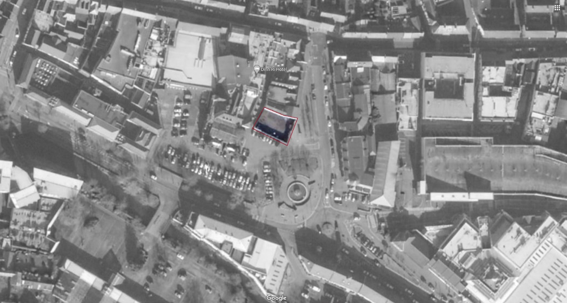
Aerial view of the proposed site outlined in red.

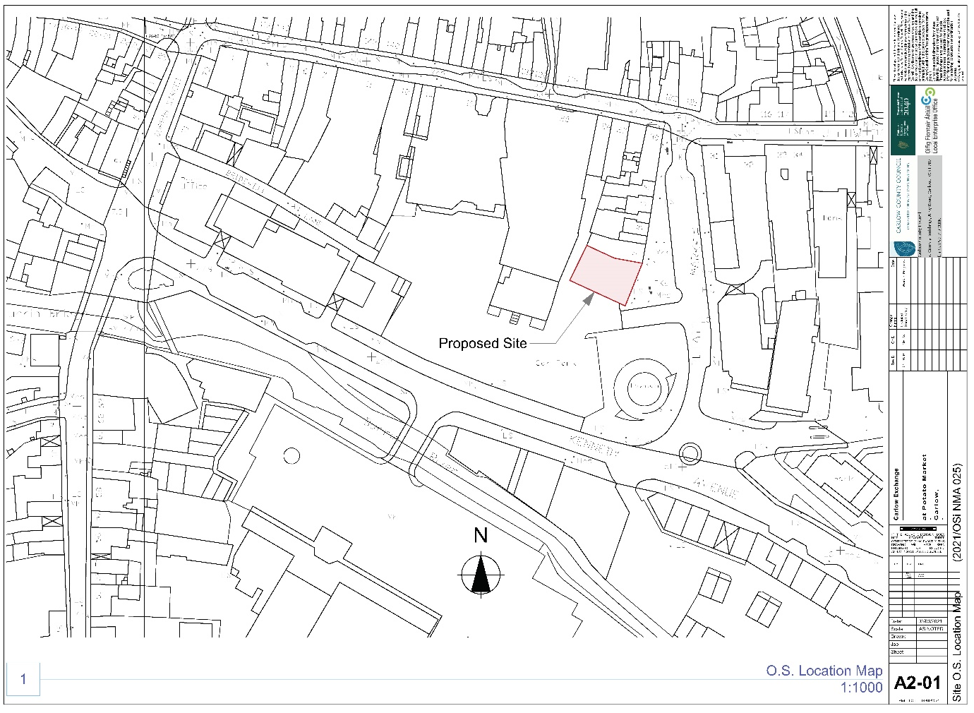
Ordinance Survey Map showing the site location

